

**Tobor**

Email automation

Detailed Process Description

Version 0.1

Revision History

|  |  |  |  |
| --- | --- | --- | --- |
| **Date Issued** | **Version** | **Description** | **Author** |
| 12/06/2020 | 0.1 | Draft | Premal Nayee |
| *Date* | *Version Number* | *Draft / Final etc.* | *Name* |
| *Date* | *Version Number* | *Draft / Final etc.* | *Name* |

Contributors

The content of this document has been authored with the combined input of the following group of key individuals.

|  |  |  |
| --- | --- | --- |
| **Name** | **Role** | **Area** |
| Roberto Fernandez | Application Manager and Project PM | Backend / Tobor Inc |
| *Name* | *Job Title* | *Dept / Company* |
| *Name* | *Job Title* | *Dept / Company* |

Business Sign-off

The following table contains the people required to sign-off and/or review this document and those that require the document for information only.

|  |  |  |
| --- | --- | --- |
| **Name** | **Department** | **Responsibility** |
| *Name* | *Department* | *Information / Sign off / Review* |
| *Name* | *Department* | *Information / Sign off / Review* |
| *Name* | *Department* | *Information / Sign off / Review* |

Document Classification

|  |  |
| --- | --- |
| **Classification** | *e.g. Company Confidential* |
| Definition | *e.g. Information is company confidential and needs to be protected* |
| Context | *e.g. Where loss of information confidentiality would result in significant harm to the interests of the Organisation, financial loss, embarrassment or loss of information* |
|  |  |

Contents

1 Introduction 4

2 Manual Process 4

2.1 Overview 4

2.2 Detailed Process Flow 4

3 Automation Proposal 4

3.1 Overview 4

3.2 Automated Process Flow 4

3.3 Target Systems & User Requirements 4

3.4 Impacted Business Areas 5

3.5 Workload 5

3.6 Operational Constraints 5

3.7 Delivery 5

3.8 Contact List 5

4 Automation Details 6

4.1 Automation Walkthrough 6

4.1.1 *First robot action* 6

4.1.2 *second robot action* 6

4.1.3 *third robot action etc.* 6

4.2 Reporting 6

4.2.1 Business Exceptions 6

4.2.2 System Exceptions 6

4.2.3 Performance 7

4.2.4 Triggers 8

# 1 Introduction

*Background to the situation and an overview of the opportunity for automation.*

Tobor Inc has recently released a new app which has generated more users than expected. The process of adding new users is labour some so much so that the backend application manager is spending approximately 50% of his day. The process of adding new users requires obtaining information from emails and manually entering the user’s details into the internal systems. After which the users periodically receive content.

# 2 Manual Process

## 2.1 Overview

*Overview of the manual process as it stands currently. Includes bullet pointed list of high-level steps to take to run the process.:*

* *Step 1*
* *Step 2*
* *Step 3*
* *etc.*

*Acronyms – detail the meanings of any acronyms used above e.g. systems, clients etc.*

* Step 1: Look through inbox and sort emails by the action to be carried out
* Step 2a: With the emails that are asking to add user, then extract fields from emails and add user to the content delivery system
* Step 2b: With the emails that are asking to remove or update user details, then extract the relevant fields and make the necessary changes to the internal system
* Step 3: Periodically web scrape content websites (sport, tech and hobbies) for articles to present to users
* Step 4: Periodically send unique emails to users on their requested content type

## 2.2 Detailed Process Flow

*Detailed flow diagram covering* ***all*** *steps in the current manual process*

User imitation

Administration

Aggregation

Aggregate content from different sites and store to database

Sort the QA mailbox for user requests, by the action that should be taken

Web scrape user details from bestrandoms.com

Send emails from that imitate the registering of each user

Send users content based on their preferences

Add/Update user details to the database

# 3 Automation Proposal

## 3.1 Overview

*High level overview of the proposed automation, including detail around the type of automation*

The process will be automated using UiPath. It will include integration with MS outlook and will be scheduled to run every day. It will scrape web pages daily for content on to give to users and will associate a unique ID with each article.

## 3.2 Automated Process Flow

*If the automation process flow adheres to the manual process flow above, there is little need to duplicate. A statement to that effect should suffice, confirming all actions will be automated. Otherwise, a detailed flow should be presented.*

Manual process will be automated where each step will run as an independent process, periodically executed in a queue in UiPath Orchestrator.

## 3.3 Target Systems & User Requirements

| Name | Description | User Permissions/Access |
| --- | --- | --- |
| MS Outlook | Email Inbox | Robot will require read/write access to the QA mailbox to send and receive emails to everyone in the office. Cannot change UI. |
| Gmail | Email provider | Robot will require read/write access to the QA mailbox to send and receive emails to everyone in the office. Cannot change UI. |
| Bestrandoms.com | Fake name generator | Generates random names and addresses. Cannot change UI. |
|  |  |  |

## 3.4 Impacted Business Areas

* *Department / Areas affected by the automation*
* Mostly backend team will notice the difference
* Users may notice requests will be fulfilled quicker

## 3.5 Workload

*Metrics related to the automation, table example below*

|  |  |
| --- | --- |
| *Number of Users* | *50* |
| *Average of emails sent to each user daily* | *2* |
| *Average no. of Login Requests per week* | *50* |
| *Are there any periods when a higher workload is anticipated?* | *During events* |
| *How many people do this process per week?* | *1* |

***Summary of average time process takes a user to run manually, include timings of any dependant parts such as responses coming back from 3rd parties.***

***Automating the steps below will realise an average time saving of 4 hours per day or 20 hours per week for the administration of users and distribution of content:***

* *List of manual steps with manual execution time (Breakdown of all time saved)*

*Acronyms – detail the meanings of any acronyms used above e.g. systems, clients etc.*

## 3.6 Operational Constraints

* *List of all operational constraints. Examples could be working hours, system availability etc. – essentially anything that could have a bearing on how the automation can function.*
* Processes will run daily in a queue

## 3.7 Delivery

*The time scale for the development, testing and delivery of this project. In the early stages this may indicate the timescale is to be finalised.*

An MVP is expected by 26/06/20. After which work will begin on integrating the automation to the backend of the app.

## 3.8 Contact List

*List of key contacts for the project, both QA Ltd and Client e.g.*

*David Bradbury – Managing Director*

*Roberto Fernandez – Backend Application Manage and Project PM*

[*Robert.toborinc@gmail.com*](mailto:Robert.toborinc@gmail.com)

*Chris Lucas – Consultant Project Liaison*[*chris.lucas@qa.com*](mailto:chris.lucas@qa.com)

*Premal Nayee - Consultant*  
[*pnayee@qa.com*](mailto:pnayee@qa.com)

# 4 Automation Details

## 4.1 Automation Walkthrough

### 4.1.1 *First robot action*

* *Description of first Robot step to complete action, include screenshots where necessary*
* *Description of second Robot step to complete action, include screenshots where necessary*
* *Etc.*

### 4.1.2 *second robot action*

* *Description of first Robot step to complete action, include screenshots where necessary*
* *Description of second Robot step to complete action, include screenshots where necessary*
* *Etc.*

### 4.1.3 *third robot action etc.*

* *Continue as required to complete all Robot actions within the automation*

## 4.2 Reporting

### 4.2.1 Business Exceptions

|  |  |
| --- | --- |
| Exception | Solution |
| *List of expected or assumed exceptions* | *Details of method of handling exception* |
|  |  |
|  |  |
|  |  |
|  |  |
|  |  |

### 4.2.2 System Exceptions

|  |  |
| --- | --- |
| Exception | Solution |
| *List of expected or assumed exceptions* | *Details of method of handling exception* |

A performance report will be emailed to *<Client Contact>* each time the process runs (showing worked cases, exceptions and a cumulative processing log)

### 4.2.3 Performance

Once the processes have successfully completed a performance report and processing log will be emailed to *<Client Contact>* as an excel file.

**Performance Report**

This will contain all exceptions (business and system) and successes for the automated Process, based on the last automation execution completion (i.e. based on the last time the process ran)

EXAMPLE REPORT

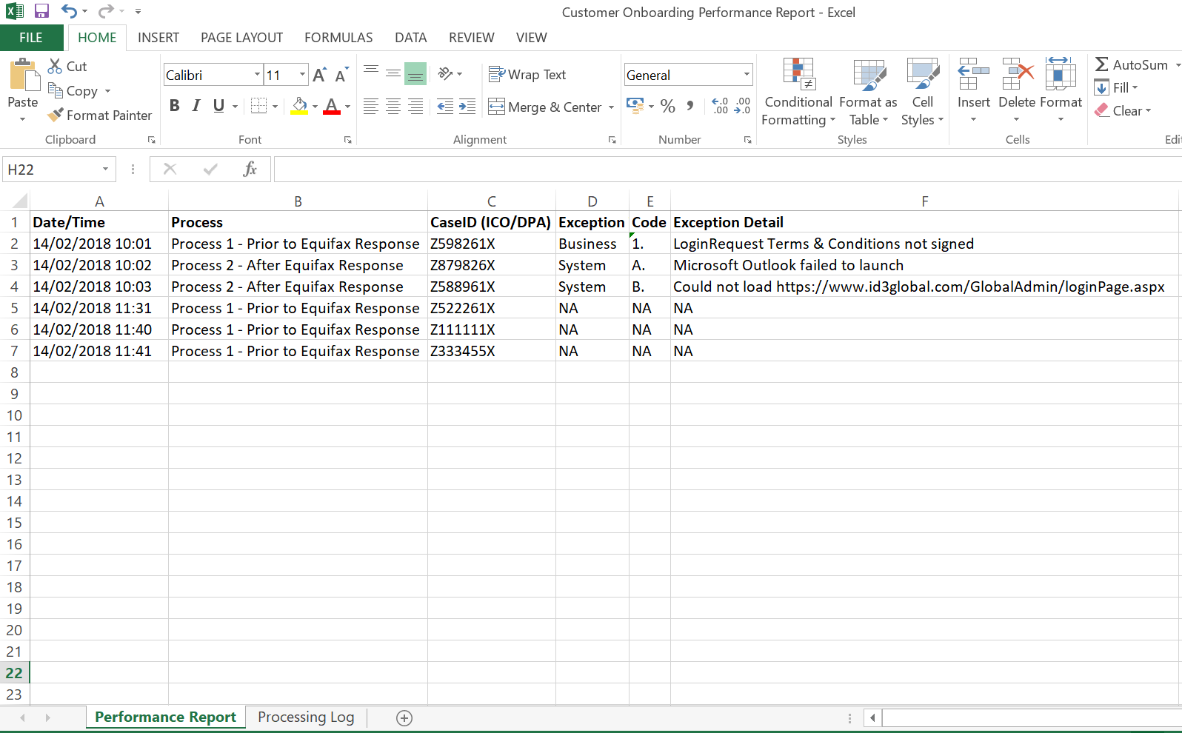

CredBest

CredBest

CredBest

CredBest

CredBest

CredBest

www.xip.com/Admin/loginPage.aspx

**Processing Log**

This will show cumulative successes from the automated Process:

EXAMPLE REPORT

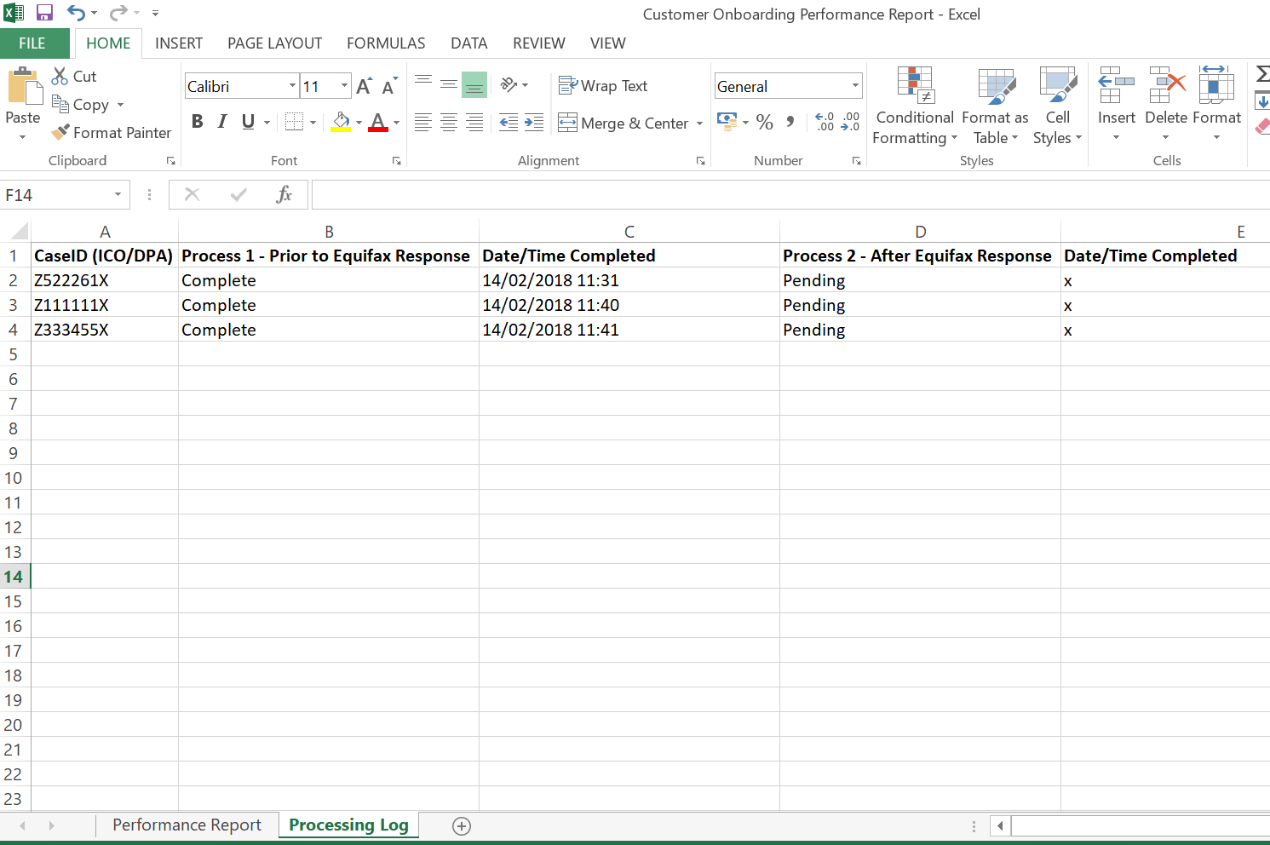

**CredBest**

**CredBest**

### 4.2.4 Triggers

*Definition of how the Robot will be triggered. This could simply define that this is a manual trigger i.e. an attended start, or could indicate more advanced triggers such as on a particular event or schedule.*

**UPDATE THE TABLE OF CONTENTS AND ENSURE ALL RED TEXT HAS BEEN UPDATED/REMOVED PRIOR TO DISTRIBUTION**